In case of reply
The number and date of this
Letter should be quoted

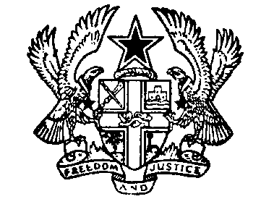

Registrar-General’s Department
Ministry of Justice
Our Ref No: BH/D/01
Your ref No ……………….…………...
Tel (233-21) 664691/3/ 664279
Fax (233-21) 666081/662043
P.O. Box 8
Accra.
Republic of Ghana
Email:info@registrargeneralgh.com

18th March, 2021.

PRESS RELEASE
FINAL NOTICE ON DELETION OF DORMANT COMPANIES FROM THE REGISTER
The Registrar-General’s Department wishes to inform all Directors, Shareholders, Company Secretaries of Public/Private Companies Limited by Shares, Private Unlimited Companies, Companies Limited by Guarantee and External Companies that this is the FINAL NOTICE to all Companies on its intended cleanup exercise of delisting dormant Companies from the Companies database.
This Final Notice is a follow up to two earlier notices issued on 12th May and on 1st December, 2020 in the National Dailies and the Department’s website respectively to remind Companies about the cleanup of the Companies Register. Companies therefore have between now and 30th June, 2021 to comply with this directive.
The exercise has become necessary as a result of the Department’s database being over bloated with names of 740,628 dormant Companies registered between 1963 to 2011, (Legacy database), with only 70,346 being updated into our new database. The rest of the Companies have neither ever filed their Annual Returns nor Re-registered with the Department.
More so, only 266,765 Companies have filed their Annual Returns out of the total 524,006 Companies registered in the new Company database (eRegistrar) since 2012 to 2020. This renders the rest of Companies not in good standing with the Department.
Provisions under Section 289 of the Companies Act 2019, (Act 992) connotes that a Company can be stricken off the Register due to the failure of the Company to file its Annual Returns on time or due to a change in the Company’s Registered Office and Principal Place of Business without notifying the Registrar of Companies timeously.
Furthermore, the Companies Act mandates the Registrar of Companies to notify the General Public with three notices after which a grace period of 3months would be given to make all the mandatory filings after the final notice.
“After the expiration of the 3 month from the date of the Notice, the names of the Companies/Partnerships that have still failed to comply with the moratoriums granted WOULD BE STRICKEN OFF THE REGISTER and the Company would be deemed DISSOLVED”.
The Department hereby urges all clients to visit our website www.rgd.gov.gh, click on News and Scroll down to view the list of Companies the Registrar intends to strike off the Register.
Companies must take the necessary steps to act on this FINAL NOTICE, as the Department would deem Companies that do not update their records as not carrying on business or not in operation and unless cause is shown to the contrary be stricken off the Register.
For further inquiries, please contact the Public Relations Unit on 055-765-3130.

SIGNED.
JEMIMA OWARE (MRS.)
REGISTRAR-GENERAL

